Geometry: Unit 9, Lesson 1
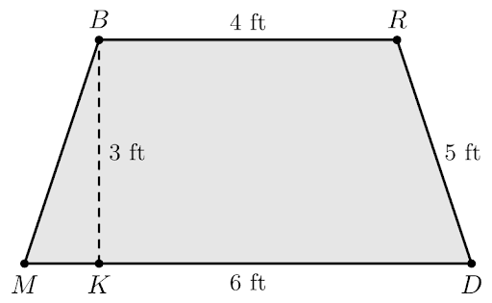
- Trapezoid $BRDM$ is shown where $BR=4$ feet $(ft.)$, $MD=6 ft$, $RD=5 ft$, and $BK=3 ft$. What is an expression that can be used to determine the area of trapezoid $BRDM$?

$$\frac{1}{2}(3)(6+4)$$

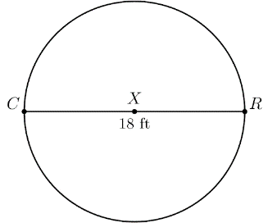
- Circle $X$ is shown where diameter $CR=18$ feet $(ft.)$. What is the area of circle $X$?

$$254.34 ft^{2}$$
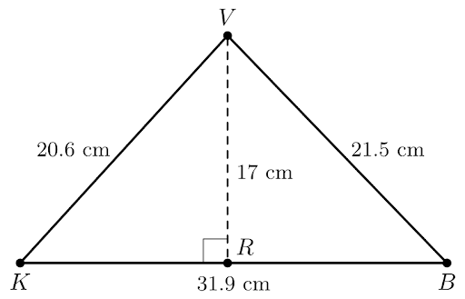
- Triangle $VKB$ is shown where $VK=20.6$ centimeters $(cm)$. $VB=21.5 cm$, $BK=31.9 cm$, and $VR=17 cm$. What is the area of $∆VKB$

$$271.15 cm^{2}$$

